Assessments

Three cognitive tasks will be selected at random to fill the 30-minute time slot for each participant. These three tasks are the attention network test (ANT), a dual-n-back task, and the Open-Source Anticipated Response Inhibition (OSARI) task. These tasks are described below.

**ANT**

The attention network test assesses three areas of attention: alerting, orienting, and executive function. In this experiment, a participant is shown the fixation cross at the center of the screen, then a set of five arrows is presented in the top or bottom portion of the screen. The participant is instructed to press the left arrow key if the center arrow in the string of five arrows is pointing left, and the right arrow key if the center arrow is pointing right. In some trials, a square will be presented at the same time as the fixation cross, placed either above or below the cross, serving as a cue for where the arrows will next be located. In other trials, the fixation cross is presented at the center of the screen, then the box is presented at the center of the screen, and finally the arrows are presented in the top or bottom portions of the screen. When the string of stimuli is presented, the participants will see either a neutral, congruent, or incongruent trial (see below). The participants have a practice round, where they are shown their accuracy and response time after each trial. After the practice round is complete, the participants begin the real trials, where response times and accuracy are recorded, but the feedback is not presented to the participants. Examples of these different trials are seen below:

**Dual-N-Back**

The dual-n-back procedure tests a participant’s working memory by requiring the participant to remember two pieces of information about a series of stimuli. In this experiment, participants will be presented with both an auditory and visual cue. For the auditory cue, the participant will hear the letter “P,” Y,” or “O.” For the visual cue, three blue doors will be presented, with one of these doors turning red for each trial. The participants are instructed to remember the series of both stimuli and press a specific key if either the letter or door was used two trials before the current presentation. After a series of practice rounds, the participants will complete the dual-n-back trials, and the response times and accuracies will be recorded. An example trial is pictured below.

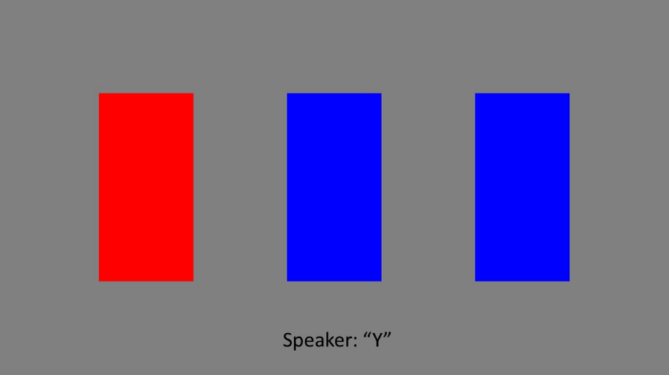

**OSARI**

The OSARI is an assessment of executive control with a combination of go and stop trials. In go trials, a participant is instructed to stop a filling bar at a target, as indicated by arrows. An example of this is seen below.

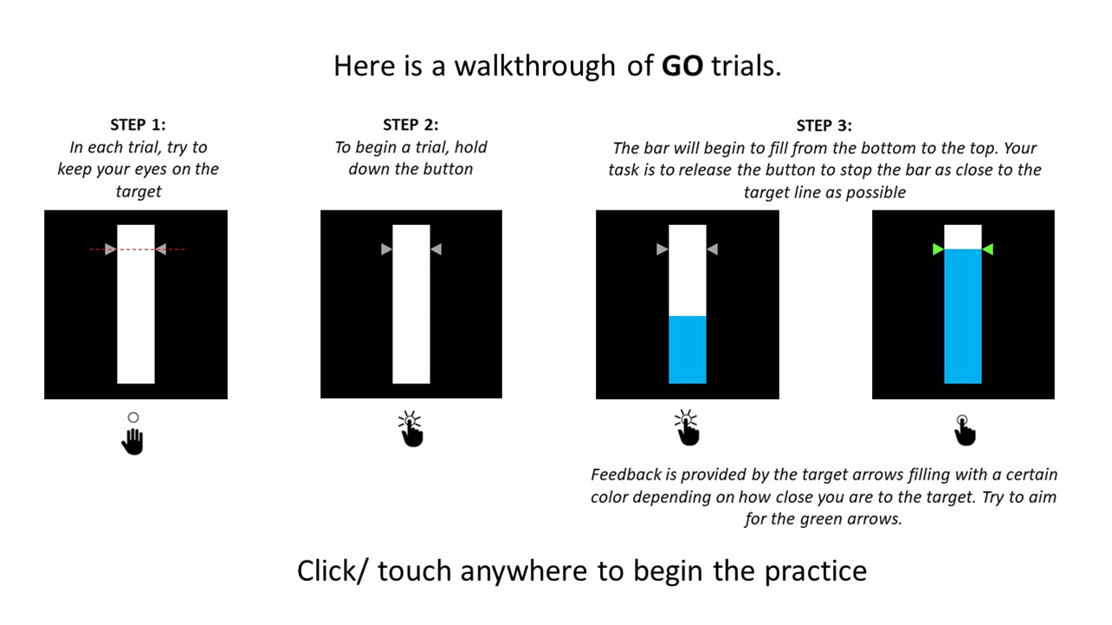

In stop trials, the bar will randomly stop filling. In these trials, the participants have to try and lift the key in accordance with the color change of the arrows, as seen below.

As with the other neurocognitive assessments, response times and accuracy will be recorded.